Project Report for Web Design & Development
Contents
1 Introduction 2
2 Link to Github Repo 2
3 Installation/Usage 2
4 Use of GenAI 2
5 Image Attribution 2
6 Design Decisions Made 2
6.1 Look and Feel 2
6.2 Breakpoints 3
7 Performance 4
8 SEO 4
9 Accessibility 4
10 Wireframes 6
11 Reflection on your work 6

Introduction

I designed the site as an online souvenir shop for Bundoran, allowing users to browse products, view details, add items to the cart, and complete a checkout process. The site also includes pages such as Home, About, Contact, Login, User Details, Shop, Checkout that support a full user experience. It is fully responsive, easy to navigate, and built to give visitors a smooth and accessible way to explore and purchase items from the store.

Link to public Github Repo

https://github.com/SilvanaPSilva/wddsilvanasilva

Installation/Usage
Username = your_email_here@email.com |Password: 12345678
Credit Card number = 1234 5678 9102 3456 | CVV 123 – After completing a purchase, the user is redirected to the Thank You page. I tried to do the same for Contact Us, but it didn't work.

Use of GenAI
I use AI to correct grammar and check for errors on my product pages, and Thank You Contact redirection, though it didn't work. However, it was very helpful for creating my map and form on the Contact Page. I use Copilot to help at grammar and translate this report as well.

Image Attribution
All the images product was made by ChatGPT.

Design Decisions Made
The primary colour associated with Ireland is green, which is also featured in the uniform of Bundoran FC. Since the town, county, and country all incorporate green in their flags, I aim to represent these three entities through different shades of green. This distinction is particularly relevant as we discuss Bundoran, County Donegal, Ireland.

Look and Feel
I applied Bootstrap throughout the site to create a responsive layout. I used the Bootstrap grid system to organise product cards, forms, and page sections so they automatically adjust across mobile, tablet, and desktop screens. I also used built-in components such as the responsive navbar, buttons, forms, and utility classes to speed up development and ensure a clean design.
Toward the end of the project, I customised several Bootstrap elements to match the style of the site. This included adjusting spacing, colours, and alignment with custom CSS, adding my own classes to improve the layout, and modifying the navbar to include the logo, active-page highlighting, and a cart badge. I also combined Bootstrap with Handlebars to dynamically render content while keeping the layout responsive and visually consistent.

Breakpoints
buyIt.hbs - I implemented responsive layout using Bootstrap’s breakpoint classes. The product grid uses row-cols-1 row-cols-md-2 row-cols-lg-3, which automatically changes the number of columns at mobile, tablet, and desktop breakpoints. Additional spacing utilities such as my-2 and g-4 also adapt responsively without requiring custom media queries.
loggin.hbs - I used Bootstrap’s responsive grid system to adjust the layout at different breakpoints. For example, the form container uses col-sm and col-md-4, meaning it spans the full width on mobile devices and becomes a centered, narrower column on tablets and larger screens. This ensures the form remains readable and visually balanced across all screen sizes without requiring custom media queries.
index.hbs - The homepage carousel is fully responsive. The images use d-block w-100, which ensures they scale to 100% of the available width at every breakpoint. The Bootstrap container and carousel components automatically adjust spacing, width, and layout across mobile, tablet, and desktop screens without requiring custom media queries.
contact.hbs – Completely built with Bootstrap
checkout.hbs - The checkout page uses Bootstrap’s responsive grid system to adjust the number of items displayed per row at different breakpoints. The class combination row-cols-1 row-cols-md-2 row-cols-lg-3 ensures that the layout shows one column on mobile, two on tablets, and three on desktop screens. Additional utilities such as g-4 and justify-content-center help maintain spacing and alignment across all screen sizes without requiring custom media queries.
about.hbs - The About page uses Bootstrap’s responsive grid system to adjust the layout at different breakpoints. The section uses col-12 col-md-6, meaning the image and text stack vertically on mobile and display side-by-side on tablet and desktop screens. The image uses img-fluid to scale automatically, and additional responsive utilities such as float-md-end and ms-md-3 apply only at medium breakpoints and above. These techniques ensure a fully responsive layout without writing custom media queries.

Performance
I used Bootstrap throughout the site to create a clean and responsive layout, applying grid classes such as row-cols-1 row-cols-md-2 row-cols-lg-3 and col-12 col-md-6 to adapt the design across mobile, tablet, and desktop. I also used utilities like img-fluid, spacing classes, and Bootstrap components (navbar, cards, carousel, forms) to keep the interface consistent. Toward the end of the project, I added small custom styling adjustments and applied minification to optimise performance and reduce file size.

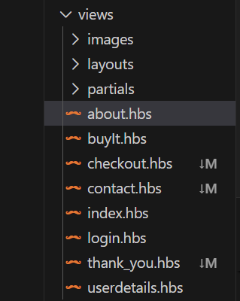
SEO
I used semantic HTML elements such as <main>, <section>, <header>, and <footer> throughout my Handlebars (.hbs) templates. These tags help search engines interpret the structure and purpose of each section, improving both accessibility and SEO.
I also organised the layout using Handlebars partials (_head.hbs, _nav.hbs, _footer.hbs), which keeps the structure consistent across all pages. This approach ensures that important SEO elements like <title> and <meta> tags are applied site-wide and makes the project easier to maintain.
Additionally, I implemented a semantic <nav> element together with Bootstrap’s responsive navbar component. The navigation automatically collapses into a mobile-friendly toggle on smaller screens and expands on larger devices. I used Handlebars conditionals to highlight the active page and added descriptive alt text to the logo to support accessibility tools.
Clean URLs - Routes such as /home, /buyIt, /about, /contact are short, readable, and SEO-friendly.
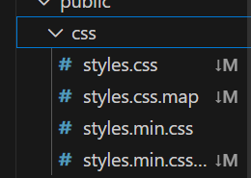
Fast Loading (Minification) - I applied minification to reduce CSS/JS file size, improving page speed — a key SEO factor.
Mobile-Friendly Layout - Bootstrap’s responsive grid ensures the site works well on all devices, which improves search ranking.
Alt Text for Images - All images include descriptive alt attributes, improving accessibility and SEO.
<div class="carousel-item">
<div class="image-wrapper shadow-lg p-5">
<img src="/images/wdmugge3.png" class="d-block w-100" alt="mug">

Accessibility
I implemented several accessibility features to ensure the site is usable for all visitors, including those using assistive technologies.
Alt Text on Images - All images include descriptive alt attributes so screen readers can describe the content. Ex.:
_nav.hbs
<div class="collapse navbar-collapse" id="navbarNav">
<ul class="navbar-nav">
<li class="nav-item">
<a class="logo-link" href="/">
<img src="images/logoheader.png" alt="Bundoran Souvenir Logo" class="nav-logo">
</a>

_about.hbs
<img class="img-fluid" src="images/Bundoran-Ireland.jpg"
class="col-md-6 float-md-end mb-3 ms-md-3 border border-2 border-primary rounded" alt="bundoran">

</div>

_index.hbs
<div class="carousel-item">
<div class="image-wrapper shadow-lg p-5">
<img src="/images/wdmugge3.png" class="d-block w-100" alt="mug">

shop.js
// Step 4_3 Element = JSON (Link)
if (typeof (productSil.img) !== 'undefined' && productSil.img.length !== 0 && productSil.img !== "unknown") {
img.src = productSil.img
// <img class='card-img-top' src="images/wdbundoransouvenir.jpg" alt="">
}

if (typeof (productSil.alt) !== 'undefined' && productSil.alt.length !== 0 && productSil.alt !== "unknown") {
img.alt = productSil.alt
// <img class='card-img-top' src="images/wdbundoransouvenir.jpg" alt="

Semantic HTML Tags - I used semantic elements such as <main>, <nav>, <header>, and <footer> to give structure and meaning to the content.
Accessible Navigation (Navbar) - The navigation uses a semantic <nav> element and Bootstrap’s responsive navbar.
Clear Labels in Forms - Forms include labels connected to their inputs, improving clarity for assistive tools.
<form name="login" id="user-login" method="get">
<div class="form-group">
<label for="emailAddressID">Email address</label>
<input type="email" class="form-control" id="emailAddressID" name="email" value="your_email_here@email.com"
required>
</div>
<div>
<label for="passwordID">Password</label>
<input type="password" class="form-control" id="passwordID" name="password" value="12345678"
required>
</div>
<div>
<input type='submit' class="btn btn-primary" value="Login">
</div>
</form>

Consistent Layout Using Handlebars Partials - Using partials (_nav.hbs, _footer.hbs, _head.hbs) ensures that accessibility features like navigation structure, meta tags, and headings are consistent across all pages.

Wireframes
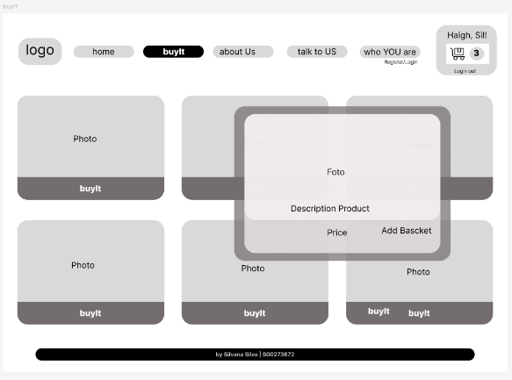
I think I accomplished most of what I planned before, but I wanted to add pop-up images as well. The idea was that, with one click, an image would enlarge and display information—floating in front of other pictures on the page. However, the code kept breaking, so I eventually gave up on this feature.
Another issue I realised quite late is that I didn't include a button to remove products from the basket. I didn't have enough time to improve it.

Reflection on your work

I had to relearn many things with the help of friends — Eliska, Shauna, and especially Valerii, who even recorded a YouTube video to help me understand GitHub and answered many of my questions about web design and JavaScript. I also had study-class days with him, which were essential for helping me work through several parts of the project when I was stuck. I learned from online tutorials as well, including videos by Gustavo Guanabara (https://youtube.com/playlist?list=PLeuwJul7tRBfsm7sxnR5_7wG3KvaQ6oOt&si=DigtL1pEgLVL_YDI). Even so, I applied what I could and pushed myself further than I expected.

